Meta title: Anchor Health Home Care: Tech-Driven Care Solutions
Meta description: Discover how Anchor Health Home Care connects families with local caregivers through innovative technology, transforming home care into a seamless, on-demand service.

Exploring Anchor Health Home Care Services
Picture this: your aging mother needs immediate help with groceries, but you live states away. While traditional agencies often face scheduling backlogs, Anchor Health Home Care leverages technology to bypass that red tape.
On-demand home care platforms function like a digital bridge rather than a corporate middleman. By utilizing peer-to-peer elderly care networks, these tools allow families to find vetted local neighbors quickly, transforming how we access support.
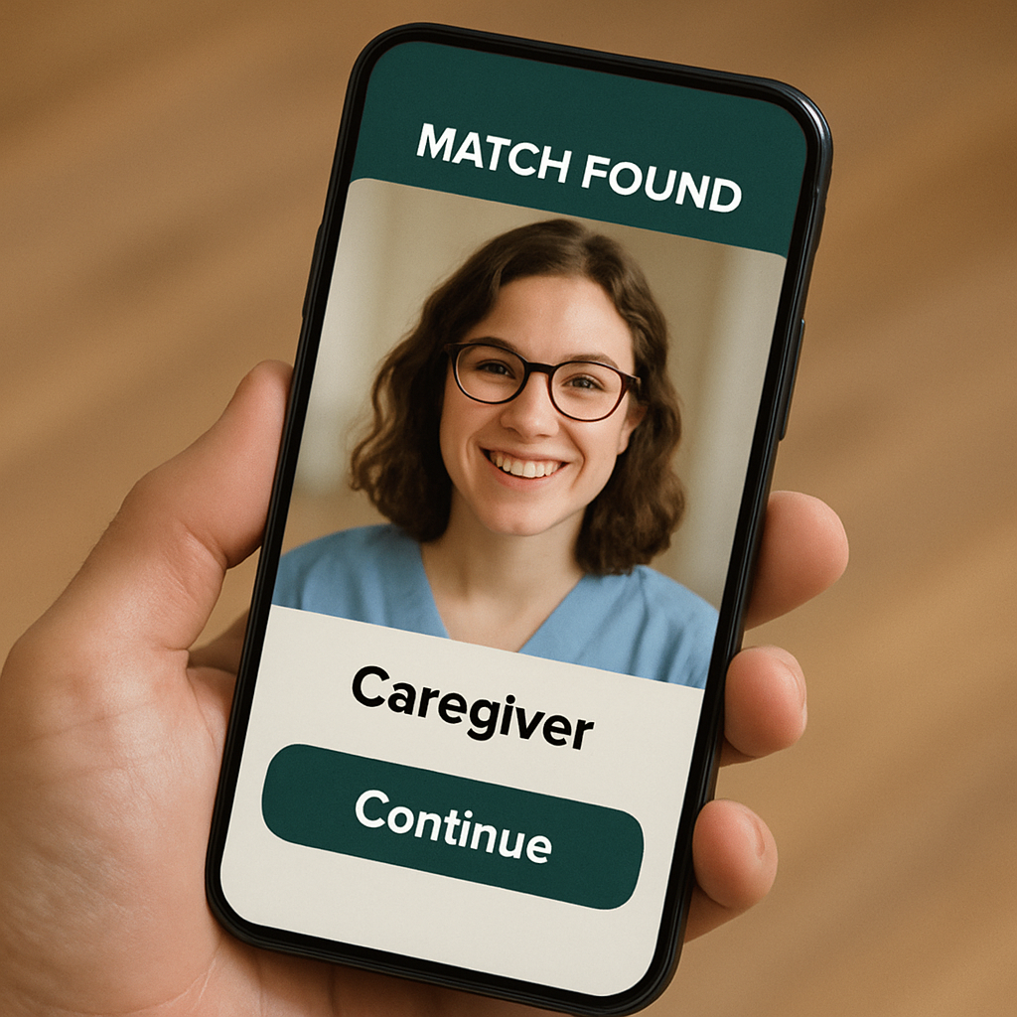

Behind the Screen: How 'Smart Matchmakers' and Digital Filters Vet Your Caregiver
Finding the right help used to mean calling five different agencies, but modern apps use caregiver matching algorithm technology to act like a smart matchmaker. The software analyzes location, specific needs, and schedules to suggest the best fit immediately. Think of it like a streaming service predicting your next favorite movie, but applied to connecting humans who need care with those who can provide it.
Before a match happens, automated background check systems for gig workers serve as a digital filter. These tools scan criminal databases and identity records, preventing applicants with history flags from ever joining the platform. While technology cannot replace your intuition, it provides a safety baseline that old classified ads never could.
Once you have a candidate, knowing how to vet independent caregivers online requires looking for four digital indicators on their profile:
- A "verified" background check badge
- A validated list of specific skills
- Reviews from previous families
- Up-to-date availability

From GPS Tracking to Secure Messaging: Keeping Your Family Safe with Real-Time Tech
Once you hire help, the biggest anxiety is often simply wondering if they arrived on time. Modern platforms use "geofencing" to create an invisible digital boundary around your home that automatically clocks the caregiver in upon arrival. This utilizes the benefits of GPS tracking in home care services to provide proof of attendance without you needing to make awkward check-up calls.
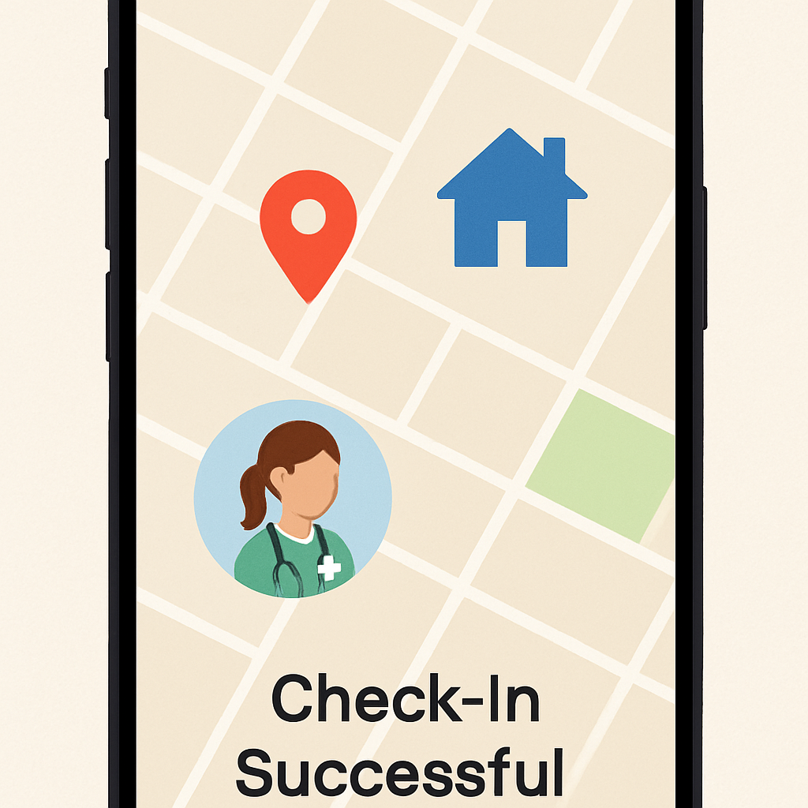
Sharing medical updates requires more privacy than standard texting provides. Apps now use HIPAA compliant messaging for care teams to ensure sensitive details, like medication schedules, are encrypted and readable only by authorized people. This keeps private health data secure while allowing for instant updates, effectively replacing the old method of leaving sticky notes on the fridge.
Such features help minimize what are the risks of hiring gig economy caregivers, specifically regarding accountability and unreliability. Advanced apps may even include remote patient monitoring tools for home health to log vitals in real-time. These digital safeguards provide the peace of mind necessary to take the next step: safely starting your journey on a new platform.

Starting Your Journey: How to Safely Switch to a Tech-Enabled Care Platform
You no longer need to rely on expensive agencies or endless phone tag to find reliable help. On-demand caregiving platforms strip away administrative overhead while keeping safety front and center. Start by downloading a reputable platform and scheduling a short "trial run" shift—perhaps just two hours for a grocery run—using the mobile app to define specific tasks beforehand. This simple step lets you test the chemistry with a caregiver and verify the immediate cost savings compared to traditional models.
As you grow comfortable with this technology, you will see it’s not just about convenience; it’s about reshaping how we support our neighbors. Whether you need occasional respite or are scaling up to daily assistance, these digital tools allow you to adjust care levels instantly. Embracing this shift puts control back in your hands, transforming a complex scheduling struggle into a seamless, human connection.

